**PERSONAL BLOG ON IBM CLOUD STATIC WEB APPS**

**Phase 4 Submission Document**

|  |  |
| --- | --- |
| NAME | KRISHNARAJ K |
| TEAM ID | 8935 |
| TEAM NAME | Proj_207157_Team_2 |
| PROJECT NAME | 8301-Personal Blog on IBM Cloud Static Web Apps |
| SUBMISSION DATE | 01-11-2023 |

**Table of Contents:**

**Introduction**

Chapter 1: Choosing the Right Static Site Generator

Chapter 2: Setting Up Your Development Environment

Chapter 3: Creating Your Blog Project

Chapter 4: Organizing Your Blog Content

Chapter 5: Customizing the Look and Feel

Chapter 6: Building and Deploying Your Blog

Website pages

Conclusion

**Introduction**:

Blogging is a popular way to share your thoughts, stories, and experiences with the world. However, managing a blog efficiently can be a daunting task. This guide will help you simplify the process by using static site generators like Jekyll and Hugo. These tools convert your HTML content into template files that are easy to update, making the management of your blog a breeze.

**Chapter 1:** Choosing the Right Static Site Generator

In this chapter, we will discuss the benefits of using static site generators like Jekyll and Hugo. You will learn how these tools work and the advantages they offer over traditional content management systems. We will help you make an informed decision on which generator suits your needs best.

**Chapter 2:** Setting Up Your Development Environment

Before you can start using Jekyll or Hugo, you need to set up your development environment. This chapter covers the installation of Ruby (for Jekyll) or Go (for Hugo), as well as installing and configuring the generators. We'll explain each step in simple terms, ensuring a smooth setup process.

**Chapter 3:** Creating Your Blog Project

In this chapter, we dive into creating your blog project. You'll learn how to initialize a new project using Jekyll or Hugo and explore the basic project structure. We'll provide step-by-step instructions for setting up your project and customizing it according to your preferences.

**Chapter 4:** Organizing Your Blog Content

One of the key advantages of using static site generators is the ease of organizing your blog content. You will learn how to create and structure your content using Markdown, a simple and human-readable language. We'll discuss best practices for writing and formatting your blog posts and explain how to use YAML or TOML front matter to add metadata to your posts.

**Chapter 5:** Customizing the Look and Feel

Your blog should reflect your style and personality. In this chapter, we'll show you how to customize the design and layout of your blog. You'll discover how to select themes, create templates, and style your blog to match your vision. We'll also discuss how to add plugins and extend the functionality of your site.

**Chapter 6:** Building and Deploying Your Blog

After creating and customizing your blog, the next step is to make it available to the world. This chapter covers the process of building your blog with Jekyll or Hugo and deploying it to the web. You'll learn how to preview your blog locally, create a production-ready version, and deploy it to hosting platforms, including GitHub Pages and Netlify.

**Website pages :-**

Home page

Discover captivating destinations, read insightful travel tips, and embark on adventures from the comfort of your screen.

About page

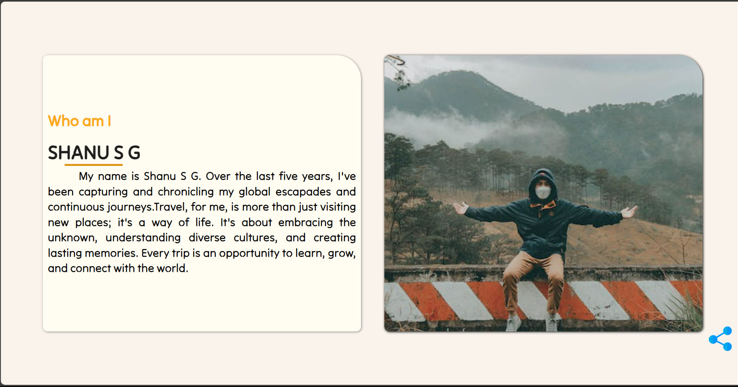We are a passionate group of explorers sharing our love for travel with the world. Learn about our journey, mission, and the individuals who bring our travel stories to life.

Blog Page

Explore the world through our eyes with the latest blog posts from us.



Travel tips page

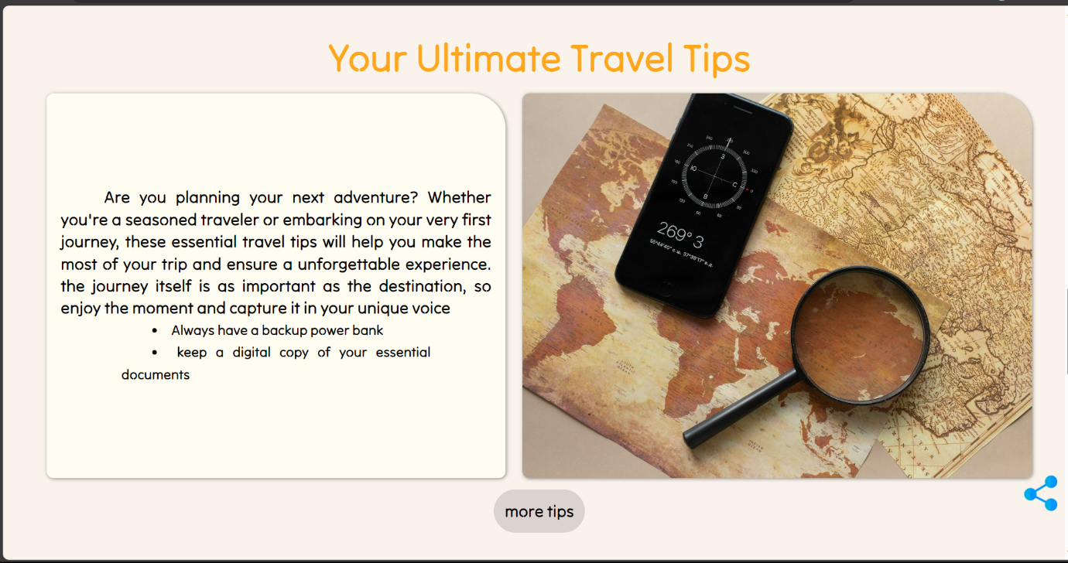Our tips page is your guide to travel wisdom, from packing hacks to cultural insights. Join us on a journey of discovery, empowerment, and the art of smart and enriching travel.

Destination page

Each destination is a unique chapter in your travel story, offering a kaleidoscope of experiences waiting to be explored.

Contact page

Your voice matters, and we're here to listen, respond, and engage with you. Whether you have questions, feedback, or simply want to reach out, drop us a message, and we'll get back to you as soon as possible.

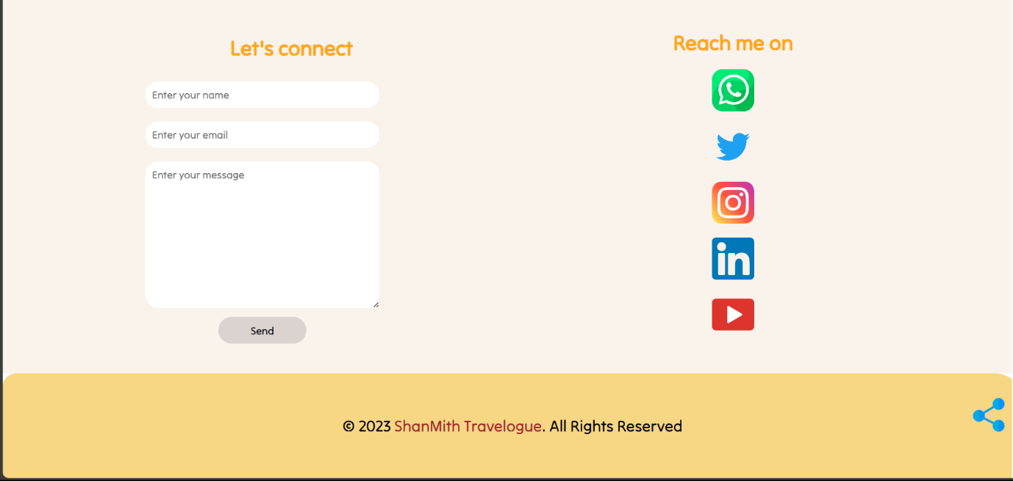

**Conclusion**

In the concluding chapter, we'll summarize the key takeaways from the guide. You'll gain an appreciation for how static site generators simplify the management of blog content. We'll encourage you to explore and experiment with Jekyll and Hugo, ultimately providing you with the confidence and knowledge to manage your blog more efficiently.This comprehensive guide will equip you with the skills and understanding needed to use Jekyll and Hugo effectively to manage your blog content. By the end of this journey, you'll be well-prepared to create, maintain, and share your blog with the world.